APB Results and Debugging- Prerna Agarwal

Simulation Result:
1st RUN
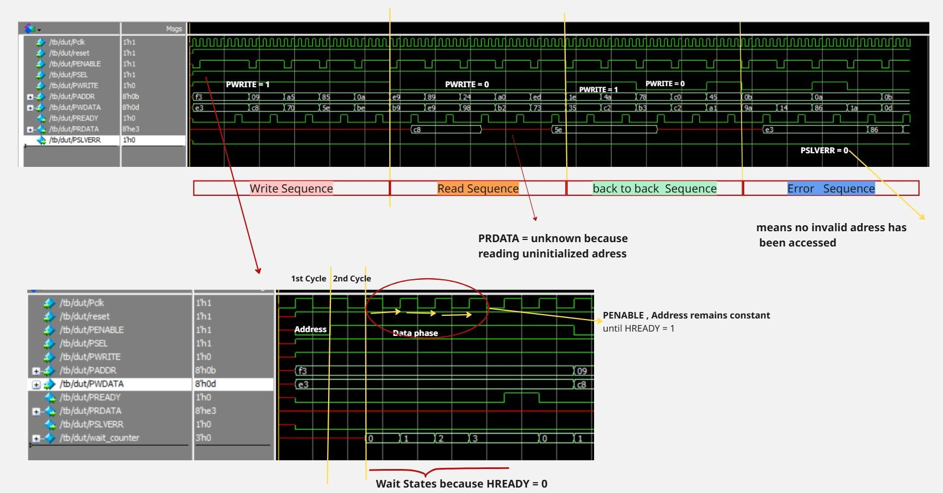

Functional Coverage Analysis

Metric | Covered | Total | % Hit | Status
Overall Covergroup | 15 | 18 | 83.33% | ❌ Uncovered

Coverpoint  Cp_write |  |  | Coverpoint  cp_data
Bin | Hits | Status | BIn | Hits | Status
READ | 21 | ✅ Covered | Zero | 21 | ✅ Covered
WRITE | 19 | ✅ Covered | others | 19 | ✅ Covered
Coverpoints cp_addr |  |  | Coverpoint  cp_error
Bin | Hits | status | Bin | Hits
Low (0-15) | 13 | ✅ Covered | no_error | 40 | ✅ Covered
Mid (16-127) | 10 | ✅ Covered | error | 0 | ❌ Missing
High(128-255) | 17 | ✅ Covered

Cross Coverage - cp_write x cp_addr

Combination | Hits | Status
READ, low | 7 | ✅ Covered
WRITE, low | 6 | ✅ Covered
READ, mid | 4 | ✅ Covered
WRITE, mid | 6 | ✅ Covered
READ, high | 10 | ✅ Covered
WRITE, high | 7 | ✅ Covered
Cross coverage = cp_write x cp_error

Combination | Hits | Status
READ, no_error | 21 | ✅ Covered
WRITE, no_error | 19 | ✅ Covered
READ, error | 0 | ❌ Missing
WRITE, error | 0 | ❌ Missing

Problems :

- The current Environment has not generated PSLVERR = 1 means NO ERROR Transaction occurred.
- Reading to uninitialized Address (showing Warnings/Error)
- Error scenarios are not covered completely. hence ,Coverage results 83%

Approaches to Solve Problems:

- Generate Error Scenarios from DUT or sequence

- Modify Slave  if( PADDR > max_valid_addr)  PSLVERR = 1; | - Force invalid access in sequence  tr.PADDR = ‘hFFFF; //invalid addr  Or  Add constraint  Constraint invalid_addr{  PADDR inside {[256:300]}; }

So I added this constraint in transaction class , Now DUT(slave) must implement this Behaviour to Flag this invalid access. Because COVERAGE can be close to 100% if DUT actually produces that behavior.

2) Fixing - “reading to uninitialized address”

Intuition- disable address randomization while reading to only test addresses which are written.
❌ Weak Verificaation Quality
❌ Lose corner case testing
❌ Never hit Error(PSLVERR)
❌ Testing to written addres only -leads to incomplete behaviour

Actually we need to decide how our DUT is supposed to behave then model and test it

- Return 0/x (PSLVERR = 0)  Current my DUT is behaving this | - Signal error PSLVERR=1 meaning Data may be invalid if reading to uninitialized address occurs

Solution applied :

In DUT: should define specification
module apb_slave #(parameter int MAX_VALID_ADDR = 255)

if(PWRITE)begin

if( PADDR >= MAX_VALID_ADDR)begin
PSLVERR <= 1; //master tired to access invalid address
end else begin
mem[PADDR[2:0]] <= PWDATA; //write
end
end
else begin
if(PADDR >= MAX_VALID_ADDR)begin
PSLVERR <=1;
end else begin
PRDATA <= mem[PADDR[2:0]]; //read
end
end

In TB: should follow those specification

parameter int MAX_VALID_ADDR = 255;

// pass to UVM world
initial begin
uvm_config_db#(int)::set(null, "*", "max_valid_addr", MAX_VALID_ADDR);
end

In Transaction:

int max_valid_addr;

function void pre_randomize();
if (!uvm_config_db#(int)::get(null, "", "max_valid_addr", max_valid_addr))
`uvm_fatal("CFG", "max_valid_addr not set");
endfunction

constraint invalid_addr {

PADDR inside {[max_valid_addr : max_valid_addr + 155]};
}

2nd RUN , Simulation Results:

Functional Coverage:
Metric | Covered | Total | % Hit | Status
Overall Covergroup | 17 | 18 | 97.22% | ❌ Uncovered

Coverpoint  Cp_write |  |  | Coverpoint  cp_data
Bin | Hits | Status | BIn | Hits | Status
READ | 21 | ✅ Covered | Zero | 21 | ✅ Covered
WRITE | 19 | ✅ Covered | others | 19 | ✅ Covered
Coverpoints cp_addr |  |  | Coverpoint  cp_error
Bin | Hits | status | Bin | Hits
Low (0-15) | 4 | ✅ Covered | no_error | 26 | ✅ Covered
Mid (16-127) | 14 | ✅ Covered | error | 14 | ✅ Covered
High(128-255) | 22 | ✅ Covered

Combination | Hits | Status
READ, low | 0 | missing
WRITE, low | 4 | ✅ Covered
READ, mid | 8 | ✅ Covered
WRITE, mid | 6 | ✅ Covered
READ, high | 13 | ✅ Covered
WRITE, high | 9 | ✅ Covered

Combination | Hits | Status
READ, no_error | 11 | ✅ Covered
WRITE, no_error | 15 | ✅ Covered
READ, error | 10 | ✅ Covered
WRITE, error | 4 | ✅ Covered

Summary of coverage result:
No read transaction generated in low address range

READ × low address

✔ Error handling fully verified

Simulation Result:
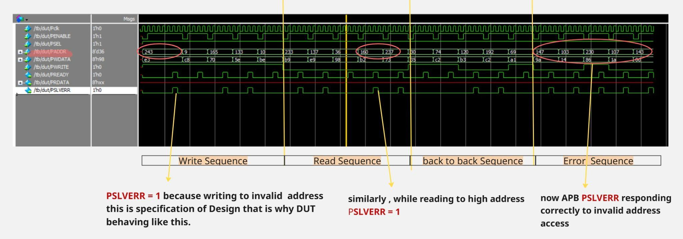

Adding Assertions:

//`include "interface.sv"

module apb_assertions(apb_inf inf);

//default clock
default clocking cb @(posedge inf.Pclk);
endclocking

// 1) setup- address phase
property setup_to_address;
disable iff (!inf.reset)
(inf.PSEL && !inf.PENABLE) |=>(inf.PSEL && inf.PENABLE);
endproperty

ass_setup_to_address: assert property(setup_to_address);
//else $error("APB: setup to address phase not followed");

//PENABLE only high when slave is selected
property penable_implies_psel;
disable iff (!inf.reset)
(inf.PENABLE) |-> (inf.PSEL);
endproperty

ass_penable_implies_psel: assert property (penable_implies_psel);

// 2) during wait state - PENABLE constant
property p_wait_state_hold;
disable iff (!inf.reset)
(inf.PSEL && inf.PENABLE && !inf.PREADY) |=> (inf.PENABLE && inf.PSEL);
endproperty

ass_wait_state_hold: assert property(p_wait_state_hold);

//PENABLE should drop after PREADY
property p_complete_transfer;
disable iff (!inf.reset)
(inf.PSEL && inf.PENABLE && inf.PREADY) |=> (!inf.PENABLE);
endproperty

ass_complete_transfer : assert property (p_complete_transfer);

//3 signal stability -
//Address Control signals stable during PENABLE is high

property p_ctrl_stable;
disable iff (!inf.reset)
(inf.PSEL && inf.PENABLE && !inf.PREADY) |-> $stable({inf.PADDR , inf.PWRITE});
endproperty
ass_ctrl_stable : assert property (p_ctrl_stable);

//PWDATA should be stable if PREADY = 0
property p_Wdata_stable;

disable iff (!inf.reset)
(inf.PSEL && inf.PENABLE && inf.PWRITE && !inf.PREADY) |-> $stable(inf.PWDATA);
endproperty
ass_Wdata_stable: assert property(p_Wdata_stable);

//Read data valid when PREADY high
property p_Rdata_valid;
disable iff(!inf.reset)
(inf.PSEL && inf.PENABLE && !inf.PWRITE && inf.PREADY) |-> !$isunknown(inf.PRDATA);
endproperty

ass_Rdata_valid: assert property(p_Rdata_valid);

//4) basic rules of APB

// when slave is not selected then PENABLE not asserted
property p_idle_rule;
disable iff (!inf.reset)
(!inf.PSEL) |-> (!inf.PENABLE);
endproperty
ass_idle_rule:assert property(p_idle_rule);

// when slave is selected then PADDR , PWRITE , PENABLE must not be X

property p_ctrl_notunknown;
disable iff (!inf.reset)
inf.PSEL |-> !$isunknown({inf.PADDR , inf.PWRITE, inf.PENABLE});
endproperty

ass_ctrl_notunknown: assert property(p_ctrl_notunknown);

// 5) ERROR handling

//no error during wait states
property p_noerror_wait;
disable iff(!inf.reset)
(inf.PSEL && inf.PENABLE && !inf.PREADY) |-> (inf.PSLVERR == 0);
endproperty

ass_noerror_wait: assert property(p_noerror_wait);

endmodule

In TB:

Bind apb_inf apb_assertions apb_assert_inst (inf);

Error encountered :

# Top level modules:
# tb
# End time: 22:51:18 on May 04,2026, Elapsed time: 0:00:00
# Errors: 0, Warnings: 0
# vsim -voptargs="+acc" tb "+UVM_TESTNAME=apb_test"
# Start time: 22:50:35 on May 04,2026
# ** Note: (vsim-3812) Design is being optimized...
# ** Error: tb.sv(14): (vopt-2907) Parameterizing 'inf' has exceeded the recursion depth limit of 10000.
# Optimization failed

Meaning:
The simulator got stuck in an infinite recursive reference involving inf (your interface)

I wrote: module apb_assertions(apb_inf inf);
Then bind: bind apb_inf apb_assertions apb_assert_inst (inf);

When we bind apb_inf ..., the tool tries to:
- Attach apb_assertions to every instance of apb_inf
- But your module itself takes apb_inf inf as a port
- That creates recursive elaboration of interface inside itself
👉 Result:
interface → assertion → interface → assertion → ... (infinite)

Error resolving-> remove bind and instantiate assertion module in TB .
This avoids recursion because:
- You are not binding to interface type
- You are connecting actual instance
apb_assertions apb_assert_inst (inf);

Commands :

vsim -voptargs="+acc" -assertdebug tb
run -all

View Assertion Report:

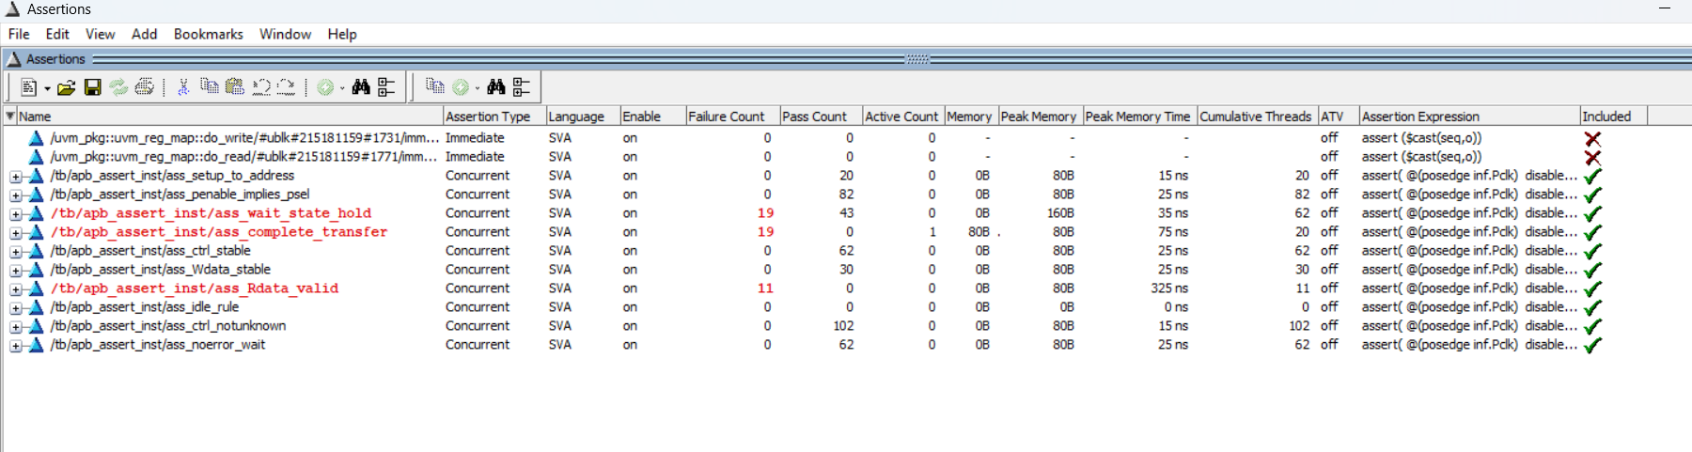

We can see assertion errors in transcript and debug it by capturing exact time given in transcript and Inspect the waveform.

